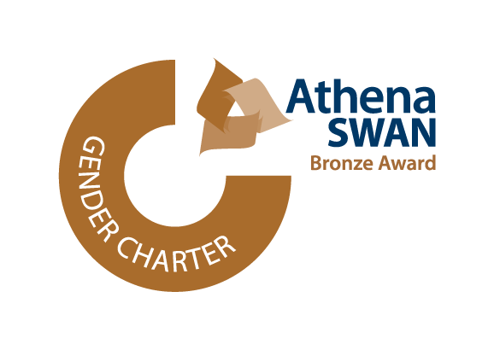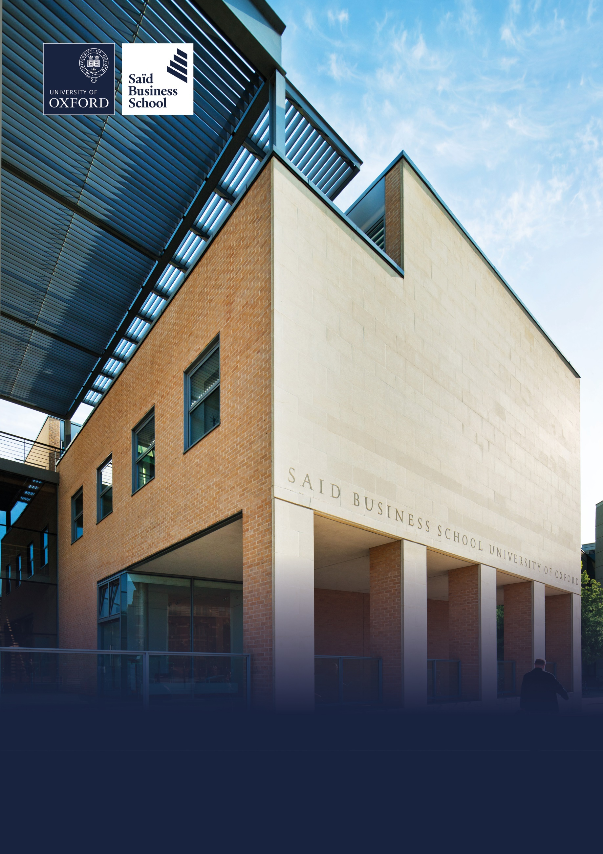

Hybrid (minimum two days per week onsite), Park End Street, Oxford

Grade 9: £55,636 - £70,029 per annum including the Oxford University Weighting of £1,500 per annum

Permanent, full time (37.5 hours per week)

Saïd Business School, University of Oxford

Associate Director, Partnerships

Executive Education

# The role

At Saïd Business School, University of Oxford, we deliver world-class executive education that transforms individuals, organisations and societies. We are now seeking an exceptional strategic leader to join our Executive Education department as Associate Director of Partnerships — a pivotal role focused on accelerating the growth of our Partnerships portfolio and deepening the value we deliver to our clients.

With a portfolio currently generating circa £8 million in annual revenue, this role offers the opportunity to influence the growth trajectory of one of the world’s most respected institutions, while contributing to Oxford’s wider mission of tackling global challenges and opportunities via world-class executive development.

The Associate Director of Partnerships is a senior leadership role within Executive Education’s Programmes and Partnerships team, as part of the Sales and Customer Relations function at Oxford Saïd, responsible for driving the growth, profitability and quality of our strategic relationships across global markets.

This role plays a critical part in enabling Executive Education to achieve its growth ambition to double revenue in three years, strengthening our position as a world leader in the global executive learning landscape. The Associate Director of Partnerships reports to the Director of Programmes and Partnerships and works closely with senior professional staff and faculty.

As a senior leader within the team, you will oversee a portfolio currently worth approximately £8 million, with responsibility for delivering sustainable annual growth of 10–20%. Your remit will include managing and expanding existing high-value relationships that expand Executive Education’s market reach in developing individual executive learners. These relationships are typically membership associations, industry bodies, academic partners and regional educational institutions.

You will be expected to lead on major commercial opportunities — proactively identifying prospects, shaping proposals and directing strategic responses to both inbound and outbound opportunities. This will include consulting with senior decision-makers to co-create impactful learning solutions, drawing from Oxford Saïd’s Corporate, Open and Online programme offerings.

Your role will require deep stakeholder engagement and a consultative sales approach, navigating complex partner requirements and aligning them with the School’s academic and commercial capabilities. You’ll lead a matrix team — drawing on the expertise of colleagues in Commercial, Learning Innovation & Impact, Programme Delivery, Product and Marketing — while acting as executive sponsor and strategic advisor to your client relationships.

You will also line manage and develop a team of Senior Client Relationship Managers, fostering a culture of high performance, collaboration and excellence in relationship leadership.

As part of your wider strategic remit, you’ll work closely with internal leads to develop channel partnership strategies for the School’s inhouse portfolio, and support cross-selling initiatives across Open Programmes, Government & Public Value Clients and Corporate Clients. Ultimately, you will be accountable for delivering outstanding client satisfaction, commercial success and long-term impact from the Partnerships portfolio.

# Responsibilities

## Drive portfolio growth

* Lead the growth and success of a Partnerships portfolio worth approximately £8 million in annual revenue, with ambitious growth targets of 10–20% year-on-year. Achieve this through deepening existing relationships and establishing new high-value partnerships.

## Strategic partnerships

* Take full accountability for the quality, profitability and strategic direction of partnership relationships. Act as a senior sponsor, ensuring robust governance, exceptional client satisfaction and alignment with Saïd Business School’s mission, strategy and values.

## Lead new business development

* Oversee the full lifecycle of new Partnership programmes — from qualification and pitching through to contracting and mobilisation. Set delivery teams up for success by aligning programme design with both client objectives and Executive Education’s business goals.

## Champion relationship excellence

* Serve as a role model for relationship management, recognised internally as a subject-matter expert. Demonstrate best-in-class client engagement, consistently delivering value and building long-term trust.

## Engage stakeholders across the School

* Build strong, collaborative relationships across Executive Education teams, including Commercial, Programme Delivery, Learning, Impact and Product Innovation, Corporate Clients and Marketing. Use outstanding communication and influencing skills to align diverse stakeholders and drive shared success.

## Lead and develop a high-performing team

* Inspire, coach and manage a team of three Senior Client Relationship Managers, empowering them to grow client portfolios and deliver excellence.

## Develop strategic channel partnerships

* Design and execute strategies to identify and activate channel partners who can support the growth of both on-campus and online open programme offerings, in close collaboration with the Open Programme Associate Directors.

## Drive innovation through technology

* Lead the adoption and implementation of technologies that enhance team performance, client relationship management and business development effectiveness.

## Contribute to cross-school growth

* Collaborate across Open Programmes, Corporate Clients and Government & Public Value Clients to cross-sell offerings, ensuring an integrated, client-centric approach that fuels overall growth of SBS Executive Education.

# Selection criteria

## Essential selection criteria

We’re looking for a strategic thinker and accomplished relationship leader with:

* A strong track record of leading high-value portfolios and securing strategic partnerships.
* Proven ability to develop and deliver growth strategies within a complex, multi-stakeholder environment.
* Expertise in executive education, professional learning or B2B consultative services.
* Excellent interpersonal, communication and influencing skills — with the gravitas to engage senior external clients and internal stakeholders.
* Outstanding interpersonal and stakeholder management skills, with a collaborative mindset and the ability to influence, engage and align multiple internal and external stakeholders toward shared goals.
* Experience leading and developing high-performing teams
* Confident with data, technology and using insight to drive performance.
* A strong team player who demonstrates effective leadership in cross-functional environments, with the ability to manage competing priorities, drive delivery and lead projects to successful outcomes.
* Resilient and well-organised, with the ability to manage multiple high-stakes assignments under pressure, navigating complexity and ambiguity while maintaining high standards of performance.
* Strong professional presence and confident networker, comfortable operating at senior levels both internally and externally across global markets.

## Desirable selection criteria

* Educated to degree level (or equivalent), ideally with a relevant professional qualification or membership of a recognised body in business, marketing, education or a related field.
* Understanding of organisational development and learning strategies, and the ability to translate this into effective executive learning solutions.
* A strong cultural fit with Oxford Saïd’s values: Transformational, Collaborative, Purposeful, Entrepreneurial, Respectful and Excellence — demonstrated in all professional interactions and outputs.

# Pre-employment screening

## Standard checks

If you are offered the post, the offer will be subject to standard pre-employment checks. You will be asked to provide: proof of your right-to-work in the UK; proof of your identity; and (if we haven’t done so already) we will contact the referees you have nominated. You will also be asked to complete a health declaration so that you can tell us about any health conditions or disabilities for which you may need us to make appropriate adjustments.

Please read the candidate notes on the University’s pre-employment screening procedures at [**https://www.jobs.ox.ac.uk/pre-employment-checks**](https://www.jobs.ox.ac.uk/pre-employment-checks).

# About the University of Oxford

Welcome to the University of Oxford. We aim to lead the world in research and education for the benefit of society both in the UK and globally. Oxford’s researchers engage with academic, commercial and cultural partners across the world to stimulate high-quality research and enable innovation through a broad range of social, policy and economic impacts.

We believe our strengths lie both in empowering individuals and teams to address fundamental questions of global significance, while providing all our staff with a welcoming and inclusive workplace that enables everyone to develop and do their best work. Recognising that diversity is our strength, vital for innovation and creativity, we aspire to build a truly diverse community which values and respects every individual’s unique contribution.

While we have long traditions of scholarship, we are also forward-looking, creative and cutting-edge. Oxford is one of Europe’s most entrepreneurial universities and we rank first in the UK for university spin-outs, and in recent years we have spun out 15-20 new companies every year. We are also recognised as leaders in support for social enterprise.

Join us and you will find a unique, democratic and international community, a great range of staff benefits and access to a vibrant array of cultural activities in the beautiful city of Oxford. For more information, please visit [**www.ox.ac.uk/about/organisation**](http://www.ox.ac.uk/about/organisation).

# Saïd Business School

Saïd Business School blends the best of new and old. We are a vibrant and innovative business school, but yet deeply embedded in an 800 year old world-class university. We create programmes and ideas that have global impact. We educate people for successful business careers, and as a community seek to tackle world-scale problems.

We deliver cutting-edge programmes, including the highly regarded MBA, Executive MBA, a number of specialist MScs, a portfolio of custom and open programmes and accredited diplomas for executives, and we undertake ground-breaking research that transform individuals, organisations, business practice and society. We are an international and outward looking School with our programme participants coming from more than 50 countries.

We seek to be a world-class business school community, embedded in a world-class University, tackling world-scale problems.

## Sustainability

Saïd Business School is committed to the highest standards of environmental sustainability, preserving the planet for future generations and acting in a socially sustainable manner. As an employee you are expected to uphold these commitments in accordance with our Environmental Policy. You can learn more about our organisation’s sustainability efforts at: [**https://www.sbs.ox.ac.uk/about-us/school/sustainability**](https://www.sbs.ox.ac.uk/about-us/school/sustainability).

## Diversity and Inclusion

Oxford Saïd is committed to fostering an inclusive culture which promotes equality, values diversity and maintains a working, learning and social environment in which the rights and dignity of all its staff and students are respected. We recognise that the broad range of experiences that a diverse staff and student body brings strengthens our research and enhances our teaching, and that in order for Oxford to remain a world-leading institution we must continue to provide a diverse, inclusive, fair and open environment that allows everyone to grow and flourish.

Oxford Saïd holds a bronze Athena Swan award to recognise advancement of gender equality: representation, progression and success for all.

## Our Values

To better understand our Values, what behaviours demonstrate them and how they are involved in your everyday work we have created the below descriptors.

### Transformational

We challenge constructively, provoke thought, and influence and inspire others to develop.

### Respectful

We are caring, supportive, appreciative, embrace difference and value each other's opinions.

### Entrepreneurial

We embrace and encourage change and innovation. We are creative, flexible and brave.

### Collaborative

We are stronger together. We are inclusive, approachable, listen to others and value good communication.

### Purposeful

We are a community who believe in sustainable growth, and are responsible, principled and transparent.

### Excellence

We are professional, focused and aligned, and have a responsibility to do the very best we can.

## Wellbeing

Saïd Business School acknowledge the importance of wellbeing, in enabling people to thrive at work and ensure a work-life balance. It provides a number of initiatives to help support wellbeing and would encourage you to participate. At an individual level, wellbeing means recognising what helps us remain resilient and taking appropriate steps. If we experience difficulties, doing our best to rectify them and making our line manager aware of aspects that they could support us with.

Further information about Saïd Business School is available at [**www.sbs.oxford.edu**](http://www.sbs.oxford.edu).

# Social Sciences

Oxford Saïd is a department within the Social Sciences Division, one of four academic Divisions in the University, each with considerable devolved budgetary and financial authority; and responsibility for providing a broad strategic focus across its constituent disciplines.

The Social Sciences Division represents the largest grouping of social sciences in the UK: home to a number of outstanding departments and to the internationally ranked Law Faculty; all are committed to research to develop a greater understanding of all aspects of society, from the impact of political, legal and economic systems on social and economic welfare to human rights and security. That research is disseminated through innovative graduate programmes and enhances undergraduate courses. For more information please visit [**https://www.socsci.ox.ac.uk**](https://www.socsci.ox.ac.uk).

# Important information for candidates

## Data Privacy

Please note that any personal data submitted to the University as part of the job application process will be processed in accordance with the GDPR and related UK data protection legislation. For further information, please see the University’s Privacy Notice for Job Applicants at [**https://compliance.admin.ox.ac.uk/job-applicant-privacy-policy**](https://compliance.admin.ox.ac.uk/job-applicant-privacy-policy).

The University’s Policy on Data Protection is available at [**https://compliance.admin.ox.ac.uk/data-protection-policy**](https://compliance.admin.ox.ac.uk/data-protection-policy).

## The University’s policy on retirement

The University operates an Employer Justified Retirement Age (EJRA) for very senior research posts at **grade RSIV/D35 and clinical equivalents E62 and E82** of 30 September before the 70th birthday. The justification for this is explained at [**https://hr.admin.ox.ac.uk/the-ejra**](https://hr.admin.ox.ac.uk/the-ejra).

For **existing** employees, any employment beyond the retirement age is subject to approval through the procedures [**https://hr.admin.ox.ac.uk/the-ejra**](https://hr.admin.ox.ac.uk/the-ejra).

There is no normal or fixed age at which staff in posts at other grades have to retire. Staff at these grades may elect to retire in accordance with the rules of the applicable pension scheme, as may be amended from time to time.

## Equality of opportunity

Entry into employment with the University and progression within employment will be determined only by personal merit and the application of criteria which are related to the duties of each particular post and the relevant salary structure. In all cases, ability to perform the job will be the primary consideration. No applicant or member of staff shall be discriminated against because of age, disability, gender reassignment, marriage or civil partnership, pregnancy or maternity, race, religion or belief, sex or sexual orientation.

# Oxford Saïd Exclusive Benefits

## Wellbeing initiatives

Oxford Saïd runs an annual Wellbeing Day for all staff. In addition to this, there is yoga, healthy food deliveries, health MOTs and a range of other ad hoc programmes. Our excellent catering facilities provide a high standard of food, including healthy eating and vegetarian options at a subsidised cost.

## Staff Summer and Christmas parties

Oxford Saïd like to reward all of their staff for their great work and their Christmas and Summer parties are our way of saying thank you. The Christmas party is for all staff and the summer party is for staff and their immediate family members, because we know how important family is to all of us.

## Employee Assistance provider

Validium is an employee assistance and wellbeing consultancy that works in partnership with the Business School to provide staff and their immediate family with a free 24-hour per day helpline providing confidential information and counselling services on personal issues.

# University of Oxford Benefits

## Annual leave

38 days (inc. public holidays). Long service additional annual leave – up to 5 days per annum, pro rata for part time employees. Previous service within higher education sector can be recognised. An additional scheme enables staff to request to purchase up to 10 additional days in each holiday year.

## Salary and salary sacrifice schemes

The University salary and grading structure allows for annual incremental progression until a scale-bar point is reached. This incremental progression is automatic. Additionally, there are salary sacrifice schemes for bicycles and electric cars. See [**https://hr.admin.ox.ac.uk/staff-benefits**](https://hr.admin.ox.ac.uk/staff-benefits).

## Pension

If you are on an academic or academic related pay scale (grade 6 or above), you are automatically a member of USS. Employer contribution is 14.5% and Employee contribution is 6.1%.

If you are on a pay scale other than academic or academic related (grade 1-5) you are automatically a member of OSPS. Employee contribution can be between 4%- 8% and Employer contribution 6%-10%.

## University discounts

All University staff can purchase a NUS Extra discount card for £12 for 12 months (£22 for 2 years, £32 for 3 years) which gives access to numerous exclusive offers and discounts from many popular retailers. There are a wide range of other discounts from external companies available using a university card.

## University Club

Membership of the University Club is free for all University staff. The University Club offers social, sporting and hospitality facilities. Staff can also use the University Sports Centre on Iffley Road at discounted rates, including a fitness centre, powerlifting room and swimming pool. See [**www.club.ox.ac.uk**](http://www.club.ox.ac.uk) and [**https://www.sport.ox.ac.uk/**](https://www.sport.ox.ac.uk/).

## Access to Oxford buildings

Free access to a number of Oxford colleges, Botanic Gardens, Harcourt Arboretum, Wytham Woods and discount at numerous restaurants/shops.



Saïd Business School

University of Oxford

Park End Street

Oxford, OX1 1HP

Saïd Business School, University of Oxford

United Kingdom

[**www.sbs.oxford.edu**](http://www.sbs.oxford.edu/)

All information is correct at the time of going to press.

Please check our website for the most up-to-date information**.**