
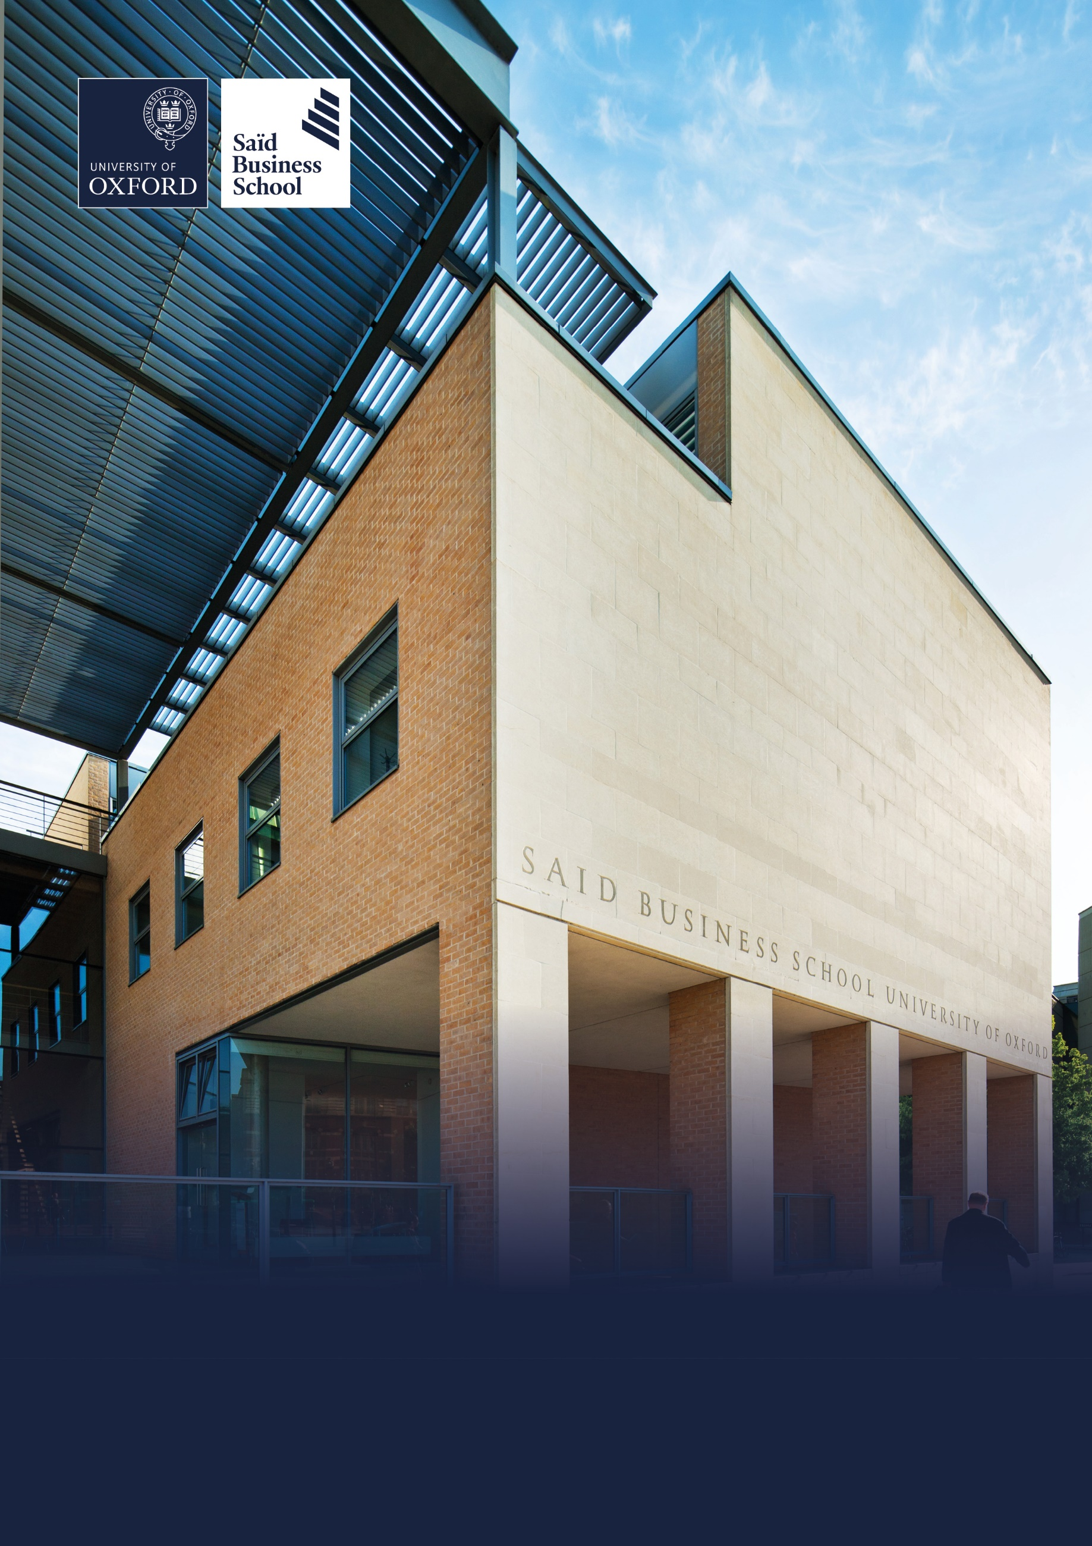

Onsite, Global Leadership Centre and Park End Street, Oxford
Grade 4: £28,437 - £32,108 per annum pro rata including the Oxford University weighting of £1,730 per annum pro rata plus shift allowance
Permanent, part time (alternating work pattern averaging 35 hours per week)
Reporting to: Guest Services Manager
Saïd Business School, Social Sciences Division, University of Oxford
Guest Services Officer (Night)


The role
The Night Guest Services Officer at the Global Leadership Centre (GLC) plays a key role in maintaining a safe, professional and welcoming environment during overnight hours, ensuring that the values and reputation of Saïd Business School are upheld at all times.

Working within the Guest Services team at the GLC, the post-holder provides front‑of‑house cover overnight (typically 21:30–07:30), acting as the first point of contact for resident guests, visitors and internal staff outside core operating hours. The role involves offering calm, well‑judged support, responding appropriately to enquiries or incidents and ensuring continuity of guest‑facing services overnight.

This position supports the School’s commitment to service excellence and contributes directly to the comfort, safety and wellbeing of senior executives, academic visitors and international programme participants. A calm, organised and proactive approach is essential to maintaining high standards, and ensuring the GLC is fully prepared and professionally presented for the start of each day.

Hours and location
Rotational night shifts patterns between 21:30 and 07:30, including weekends and bank holidays. The shift pattern is one week with three out of seven shifts and the next week with four out of seven shifts. This is a permanent, fully onsite role based at the Global Leadership Centre, with occasional onsite duties at Park End Street as operational needs require.

Responsibilities

Overnight guest interaction and support
- To represent the GLC through exemplary personal presentation and professional conduct at all times whilst on duty.

- To deliver a welcoming, attentive and proactive service to all guests, supporting a high‑quality visitor experience throughout their stay.
- Act as the first point of contact for building or first aid emergencies during the night.

- Assist with check-in and check-out processes, ensuring accuracy and efficiency.

- Provide clear information about the GLC’s facilities, programmes and services, as well as to be knowledgeable about Oxford and what the city has to offer.

- Respond promptly and helpfully to booking requests, guest enquiries or complaints received via email, phone or in person, ensuring detailed handovers to the day team and escalating when necessary to ensure guest satisfaction.

- Be knowledgeable of upcoming programmes and group bookings and be prepared for their arrival and overall stay, based on the information provided by the Programme/Conference teams.

Operational duties
- To report for duty on time for the start of the scheduled shift, well-groomed and wearing the correct uniform.

- Ensure the front desk, reception areas and guest lounges are tidy, well-stocked and professionally presented at all times.

- To take full responsibility for the night shift, leading by example and ensuring that all nightly checklist tasks and actions identified during handover are completed accurately and on time.

- Monitor access to the building, including the allocation, issue and collection of access cards and keys, and the accurate logging of arrivals and departures.

- Assist with managing room bookings, guest requests, room assignments, coordination and movement of luggage, and other special requirements in coordination with internal departments.


- Prepare and programme access cards for the following day’s arrivals and deactivate expired or returned cards in line with access control procedures.

- Accurately process transactions, including payments, daily reconciliations and maintain records in line with procedures.

- Perform regular checks and walkthroughs of reception and public areas to maintain readiness and presentation.

Maintenance and first-fix support
- Act as the first point of contact for maintenance or facilities issues reported during the night shift.

- Where appropriate, attempt first-fix interventions (e.g., adjusting room temperatures, restarting AV systems, reporting outages).

- Log all issues clearly in the helpdesk system and notify the relevant operational teams for daytime resolution.

Team collaboration
- Maintain clear communication with colleagues and contribute to a positive, team-oriented working environment.

- Assist with early morning and late evening deliveries.

- Ensure a detailed handover of all relevant information from the overnight shift is provided to the day teams and relevant departments.

- Participate in regular team meetings, briefings and training sessions to stay aligned with service standards and protocols.

Security/safety and compliance
- Respond to and record emergency situations (e.g., fire alarms, first aid incidents), escalating to on-call teams as needed.

- Act as a member of the overnight evacuation team and maintain familiarity with emergency protocols.

- Maintain the Reception emergency bag and associated logs.

- Complete security-related checks or observations as part of the overnight routine, reporting anything of concern.

- Attend or complete any mandatory and other training deemed appropriate by the Guest Services Manager, Central Services Manager or Head of Central Services.

Additional responsibilities
- Assist in conducting departmental orientation for all new Night Guest Services team members.

- Maintain up-to-date knowledge of SOPs, checklists and departmental instructions issued by the Guest Services management and other Heads of Departments and assist in training junior team members on updated operational procedures.

- To carry out other reasonable duties and to adjust to business needs as requested.

Selection criteria

Essential selection criteria
- Proven experience in a front-of-house, reception or guest-facing environment with responsibility during unsupervised or night shifts.

- Excellent verbal and written communication skills with a helpful and approachable manner.

- Ability to work overnight, making decisions and responding to issues independently.

- Basic IT literacy (e.g. Microsoft Office, email systems); willingness to learn booking/helpdesk software.

- First Aid/Fire Warden certification (or willingness to undergo provided training).

- SIA License (Security Industry Authority) or a willingness to complete training.

- Understanding of basic safety or security responsibilities in a public-facing setting.

- Willingness to work permanent, rotational night shifts (typically 21:30–07:30), including weekends and bank holidays.

Desirable selection criteria
- Experience working within a luxury hotel or premium service setting, including hands-on responsibility for night audits and financial reconciliations.

- Familiarity with property management systems (e.g. KX, Opera or similar).

- Basic maintenance awareness or practical skills related to first-fix issues (lighting, access systems, temperature, etc.)


Pre-employment screening

Standard checks
If you are offered the post, the offer will be subject to standard pre-employment checks. You will be asked to provide: proof of your right-to-work in the UK; proof of your identity; and (if we haven’t done so already) we will contact the referees you have nominated. If you have previously worked for the University we will also verify key information such as your dates of employment and reason for leaving your previous role with the department/unit where you worked. You will also be asked to complete a health declaration so that you can tell us about any health conditions or disabilities for which you may need us to make appropriate adjustments.

Please read the candidate notes on the University’s pre-employment screening procedures at Pre-employment Checks
(https://www.jobs.ox.ac.uk/pre-employment-checks).

Hazard-specific / Safety-critical duties
This job includes hazards or safety-critical activities. If you are offered the post, you will be asked to complete a health questionnaire which will be assessed by our Occupational Health Service, and the offer of employment will be subject a successful outcome of this assessment.

The hazards or safety-critical duties involved are as follows:

- Night working

- Regular manual handling, such as assisting guests with luggage, alongside performing first-response maintenance support to ensure the smooth operation of the facility.


About the University of Oxford
Welcome to the University of Oxford. We aim to lead the world in research and education for the benefit of society both in the UK and globally. Oxford’s researchers engage with academic, commercial and cultural partners across the world to stimulate high-quality research and enable innovation through a broad range of social, policy and economic impacts.

We believe our strengths lie both in empowering individuals and teams to address fundamental questions of global significance, while providing all our staff with a welcoming and inclusive workplace that enables everyone to develop and do their best work. Recognising that diversity is our strength, vital for innovation and creativity, we aspire to build a truly diverse community which values and respects every individual’s unique contribution.

While we have long traditions of scholarship, we are also forward-looking, creative and cutting-edge. Oxford is one of Europe’s most entrepreneurial universities and we rank first in the UK for university spin-outs, and in recent years we have spun out 15-20 new companies every year. We are also recognised as leaders in support for social enterprise.

Join us and you will find a unique, democratic and international community, a great range of staff benefits and access to a vibrant array of cultural activities in the beautiful city of Oxford. For more information, please visit Organisation | University of Oxford (www.ox.ac.uk/about/organisation).

Saïd Business School
Saïd Business School blends the best of new and old. We are a vibrant and innovative business school, but yet deeply embedded in an 800 year old world-class university. We create programmes and ideas that have global impact. We educate people for successful business careers, and as a community seek to tackle world-scale problems.

We deliver cutting-edge programmes, including the highly regarded MBA, Executive MBA, a number of specialist MScs, a portfolio of custom and open programmes and accredited diplomas for executives, and we undertake ground-breaking research that transform individuals, organisations, business practice and society. We are an international and outward looking School with our programme participants coming from more than 50 countries.

We seek to be a world-class business school community, embedded in a world-class University, tackling world-scale problems.

Sustainability
Saïd Business School is committed to the highest standards of environmental sustainability, preserving the planet for future generations and acting in a socially sustainable manner. As an employee you are expected to uphold these commitments in accordance with our Environmental Policy. You can learn more about our organisation’s sustainability efforts at Sustainability | Saïd Business School (https://www.sbs.ox.ac.uk/about-us/school/sustainability).

Diversity and Inclusion
Oxford Saïd is committed to fostering an inclusive culture which promotes equality, values diversity and maintains a working, learning and social environment in which the rights and dignity of all its staff and students are respected. We recognise that the broad range of experiences that a diverse staff and student body brings strengthens our research and enhances our teaching, and that in order for Oxford to remain a world-leading institution we must continue to provide a diverse, inclusive, fair and open environment that allows everyone to grow and flourish.

Oxford Saïd holds a bronze Athena Swan award to recognise advancement of gender equality: representation, progression and success for all.

Our Values
To better understand our Values, what behaviours demonstrate them and how they are involved in your everyday work we have created the below descriptors.

Transformational
We challenge constructively, provoke thought, and influence and inspire others to develop.

Respectful
We are caring, supportive, appreciative, embrace difference and value each other's opinions.

Entrepreneurial
We embrace and encourage change and innovation. We are creative, flexible and brave.

Collaborative
We are stronger together. We are inclusive, approachable, listen to others and value good communication.

Purposeful

We are a community who believe in sustainable growth, and are responsible, principled and transparent.

Excellence
We are professional, focused and aligned, and have a responsibility to do the very best we can.

Wellbeing
Saïd Business School acknowledge the importance of wellbeing, in enabling people to thrive at work and ensure a work-life balance. It provides a number of initiatives to help support wellbeing and would encourage you to participate. At an individual level, wellbeing means recognising what helps us remain resilient and taking appropriate steps. If we experience difficulties, doing our best to rectify them and making our line manager aware of aspects that they could support us with.

Further information about Saïd Business School is available at Saïd Business School (www.sbs.oxford.edu).

Social Sciences
Oxford Saïd is a department within the Social Sciences Division, one of four academic Divisions in the University, each with considerable devolved budgetary and financial authority; and responsibility for providing a broad strategic focus across its constituent disciplines.

The Social Sciences Division represents the largest grouping of social sciences in the UK: home to a number of outstanding departments and to the internationally ranked Law Faculty; all are committed to research to develop a greater understanding of all aspects of society, from the impact of political, legal and economic systems on social and economic welfare to human rights and security. That research is disseminated through innovative graduate programmes and enhances undergraduate courses. For more information please visit Social Sciences Division (https://www.socsci.ox.ac.uk).

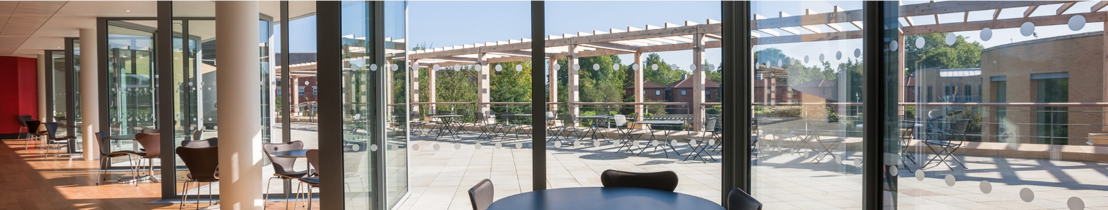
Important information for candidates

Data Privacy
Please note that any personal data submitted to the University as part of the job application process will be processed in accordance with the GDPR and related UK data protection legislation. For further information, please see the University’s Privacy Notice for Job Applicants at Job applicant privacy policy (https://compliance.admin.ox.ac.uk/job-applicant-privacy-policy).

The University’s Policy on Data Protection is available at Data protection policy (https://compliance.admin.ox.ac.uk/data-protection-policy).

The University’s policy on retirement
The University operates an Employer Justified Retirement Age (EJRA) for very senior research posts at grade RSIV/D35 and clinical equivalents E62 and E82 of 30 September before the 70th birthday. The justification for this is explained at The EJRA (https://hr.admin.ox.ac.uk/the-ejra).

For existing employees, any employment beyond the retirement age is subject to approval through the procedures. Please see The EJRA (https://hr.admin.ox.ac.uk/the-ejra).

There is no normal or fixed age at which staff in posts at other grades have to retire. Staff at these grades may elect to retire in accordance with the rules of the applicable pension scheme, as may be amended from time to time.

Equality of opportunity
The University of Oxford is committed to equal opportunity and to being a place where everyone belongs and is supported to succeed. We recognise how the diversity of our community enriches our ability to deliver on our academic mission.

We welcome applications from individuals from all backgrounds, including those underrepresented within higher education. No applicant or member of staff shall be unlawfully discriminated against on the basis of age, disability, gender reassignment, marriage or civil partnership, pregnancy or maternity, race, religion or belief, sex or sexual orientation.

Employment with the University and progression within employment will be determined according to personal merit and the application of criteria related to the duties and conditions of the post. In all cases, the primary consideration will be the ability to perform the job.

As stated in the University’s Equality Policy and Equality, Diversity and Inclusion Strategic Plan, our commitment to equality and diversity goes hand in hand with our commitment to academic freedom and free speech.


Oxford Saïd Exclusive Benefits

Wellbeing initiatives
Oxford Saïd runs an annual Wellbeing Day for all staff. In addition to this, there is yoga, healthy food deliveries, health MOTs and a range of other ad hoc programmes. Our excellent catering facilities provide a high standard of food, including healthy eating and vegetarian options at a subsidised cost.

Staff Summer and Christmas parties
Oxford Saïd like to reward all of their staff for their great work and their Christmas and Summer parties are our way of saying thank you. The Christmas party is for all staff and the summer party is for staff and their immediate family members, because we know how important family is to all of us.

Employee Assistance provider
Spectrum.Life is an employee assistance and wellbeing consultancy that works in partnership with the Business School to provide staff and their immediate family with a free 24-hour per day helpline providing confidential information and counselling services on personal issues.

University of Oxford Benefits

Annual leave
38 days (inc. public holidays). Long service additional annual leave – up to 5 days per annum, pro rata for part time employees. Previous service within higher education sector can be recognised. An additional scheme enables staff to request to purchase up to 10 additional days in each holiday year.

Salary and salary sacrifice schemes
The University salary and grading structure allows for annual incremental progression until a scale-bar point is reached. This incremental progression is automatic. Additionally, there are salary sacrifice schemes for bicycles and electric cars. See Staff benefits (https://hr.admin.ox.ac.uk/staff-benefits).

Pension
If you are on an academic or academic related pay scale (grade 6 or above), you are automatically a member of USS. Employer contribution is 14.5% and Employee contribution is 6.1%.

If you are on a pay scale other than academic or academic related (grade 1-5) you are automatically a member of OSPS. Employee contribution can be between 4%- 8% and Employer contribution 10%-14%.

University discounts
All University staff can purchase a TOTUM discount card for £14.99 for 12 months (£24.99 for 2 years, £34.99 for 3 years) which gives access to numerous exclusive offers and discounts from many popular retailers. There are a wide range of other discounts from external companies available using a university card.

University Club
Membership of the University Club is free for all University staff. The University Club offers social, sporting and hospitality facilities. Staff can also use the University Sports Centre on Iffley Road at discounted rates, including a fitness centre, powerlifting room and swimming pool. See The University Club (www.club.ox.ac.uk) and Oxford University Sport (https://www.sport.ox.ac.uk).

Access to Oxford buildings
Free access to a number of Oxford colleges, Botanic Gardens, Harcourt Arboretum, Wytham Woods and discount at numerous restaurants/shops.



Saïd Business School
University of Oxford
Park End Street
Oxford, OX1 1HP
Saïd Business School, University of Oxford
United Kingdom
www.sbs.oxford.edu

All information is correct at the time of going to press.

Please check our website for the most up-to-date information.

